2080 Citygate Drive • Columbus, OH 43219
p: 614.445.3750 │ f: 614.445.3767
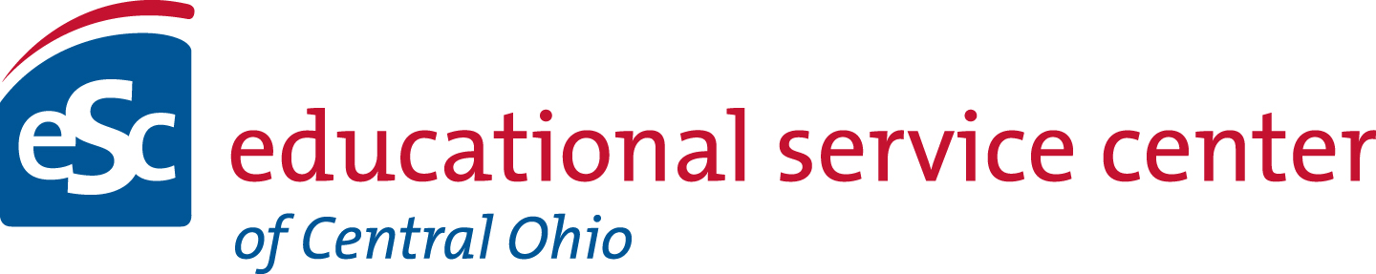
www.escofcentralohio.org

New Applicant Update for 2021-2022

The ESCCO is currently not accepting applications for new schools, replicators, or schools seeking to change sponsors. As sponsor, the ESCCO has as its priority authorizing quality community schools that meet academic, fiscal, and organizational requirements within a small portfolio. The purpose of the agency is:

PURPOSE

The ESC of Central Ohio leads when necessary, supports all stakeholders, and seeks to share and leverage resources on behalf of its client school districts and partners.
The ESCCO Community School Department supports the greater agency purpose while also providing the department’s specific mission of monitoring each of its community schools through quality sponsorship for the benefit of the students in each of the sponsored schools.
Although sponsoring is a small part of the ESCCO’s portfolio, it is dedicated to best practices for effective school choice options for parents, as supported by the National Association of Charter School Authorizers (NACSA) and has the following goals:
- Education: To monitor and assess the goals of the Education Plan of the sponsorship agreement, aligning them with the Assessment and Accountability Plan.
- Governance: To monitor and assist with governance compliance.
- Finance: To monitor and provide feedback for fiscal viability and sustainability, providing intervention if needed.
- Accountability: To monitor and evaluate legal compliance as well as areas of the contract.
- Technical Assistance: To provide technical assistance in all aspects of successful school programming.
If an application window opens and a school is added to the ESCCO portfolio, that information will be updated on this webpage. All application information including processes and timelines can be found in the guidance document located on the ESCCO Department of Community Schools webpage.

Thank you for your interest in ESCCO Community School Sponsorship!

