

**Setting a Password and Enrolling in Courses in Canvas**

After requesting a Canvas account and receiving notification that it has been created, follow these steps to enroll in courses in Canvas.

**Set Your Canvas Password:**

1. Go to <https://escco.instructure.com>.
2. Click on the ***Forgot Password?*** link.

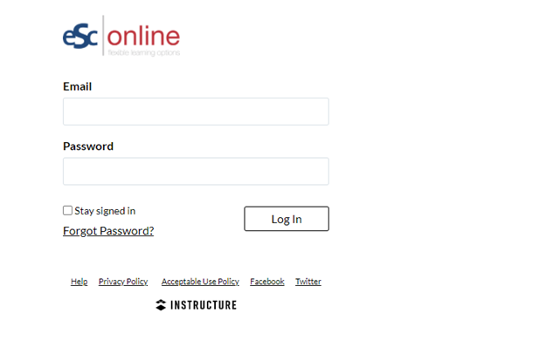

1. Type your ESC email address in the ***Email*** box.
2. Click on the ***Request Password*** button.

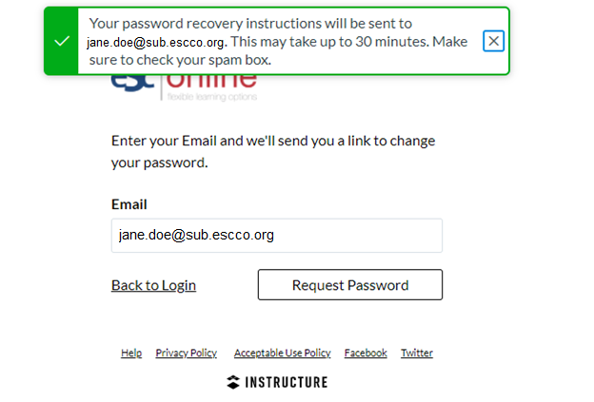

1. Check your ESC email inbox for a message from ESC Online. Note that it may take **up to 30 minutes** to receive the message that contains the ***Click Here to Set a New Password*** link. Click on the ***Click Here to Set a New Password*** contained within the message from ESC Online.

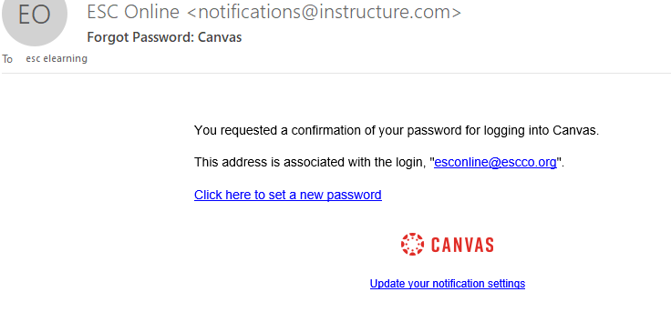

1. After clicking on the ***Click Here to Set a New Password*** link, type your password in both the ***New Password*** and ***Confirm New Password*** boxes. Next, click on the ***Update Password*** button.

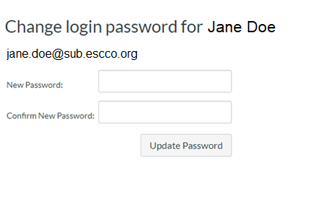

**Please do NOT log in to Canvas at this step. You will not have any courses available to complete until you follow the course registration links provided in the next section.**

**Enroll in Courses:**

1. To enroll in a course in Canvas, click on the self-enrollment link for the course that you wish to take below.
   * Google Classroom
     + [**https://escco.instructure.com/enroll/P76JGA**](https://escco.instructure.com/enroll/P76JGA)
   * Google Docs
     + [**https://escco.instructure.com/enroll/FE3P3K**](https://escco.instructure.com/enroll/FE3P3K)
   * Google Drive
     + [**https://escco.instructure.com/enroll/JMPHT6**](https://escco.instructure.com/enroll/JMPHT6)
   * Google Forms
     + [**https://escco.instructure.com/enroll/LKMNTR**](https://escco.instructure.com/enroll/LKMNTR)
   * Google Slides
     + [**https://escco.instructure.com/enroll/FBEKCP**](https://escco.instructure.com/enroll/FBEKCP)
   * Growing with Canvas
     + [**https://escco.instructure.com/enroll/GEK6HT**](https://escco.instructure.com/enroll/GEK6HT)
2. In the *Enroll in* [course title] box, type your email address in the ***Email*** box and the password that you just created in the ***Password*** box. Then, click on the blue ***Enroll*** ***in Course*** button.

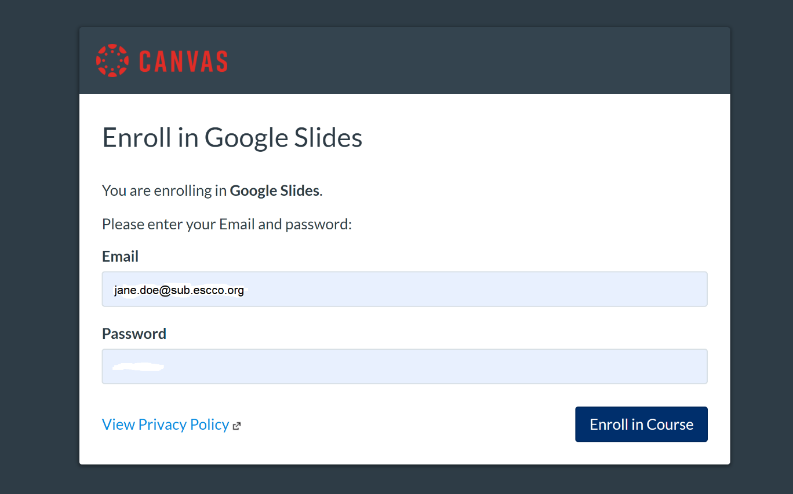

1. Agree to the Acceptable Use Policy. Then, click on the blue ***Submit*** button.

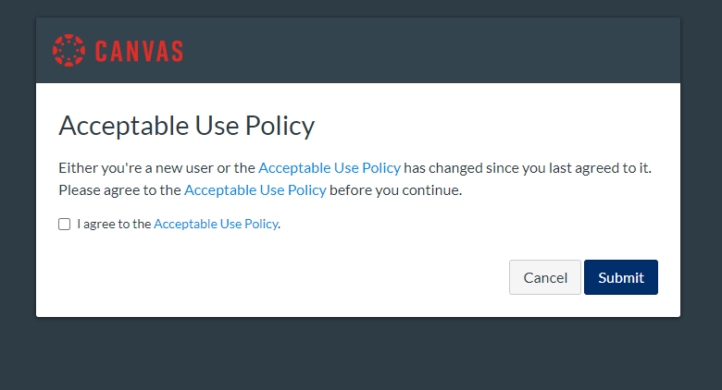

1. You will see a message that indicates that you have been successfully enrolled in the course that you selected. Click on the blue ***Go to the Course*** button.

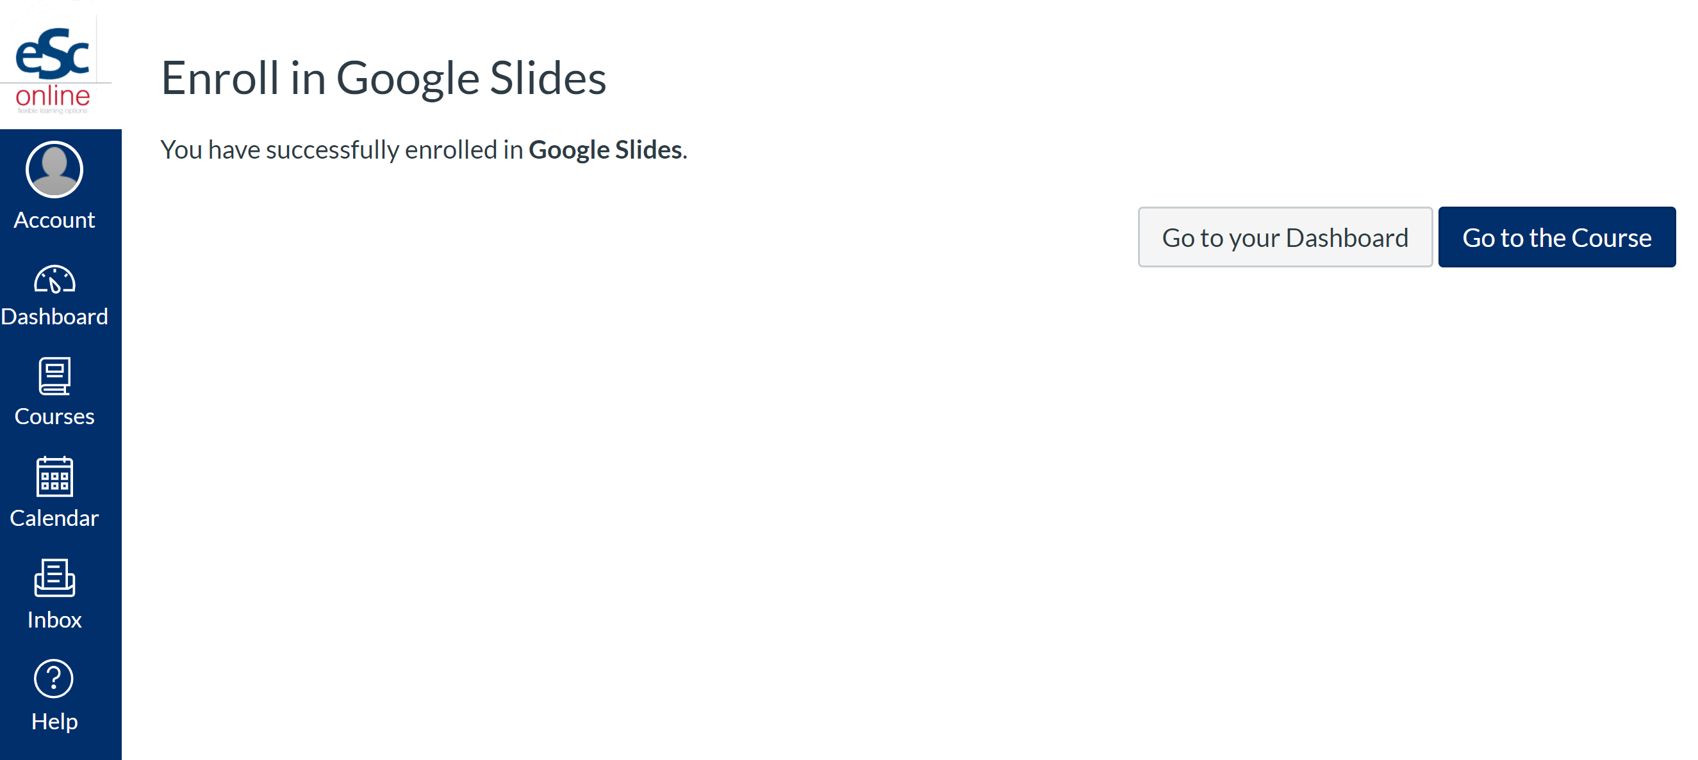

1. After you have set your password and enrolled in the course(s) that you wish to take, please watch the [Canvas Navigation](https://www.youtube.com/watch?v=HnVM-17GvG8&feature=youtu.be) video before beginning your course(s).

If you have any questions, please contact ESC Online at [esconline@escco.org](mailto:esconline@escco.org).

Enjoy the course(s)!